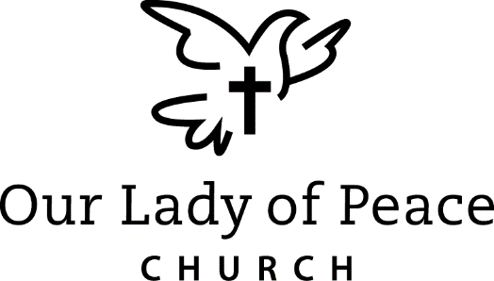

First Communion Retreat
April 4th, 2020
9:30-12:00
OLP Church
Parents are not required to attend.
Students will be making their pew signs at the retreat so please make every effort for them to be there.

If your child was not baptized at Our Lady of Peace Church please provide a copy of your child's baptismal certificate. Make sure mother's maiden name is on the certificate, if not, please write it somewhere on the paper. (Copies of the baptismal certificates given to the school are not forwarded to the Faith Formation Office.)

