OUR LADY OF PEACE

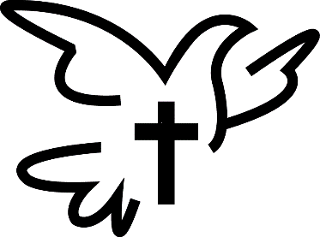

FIRST EUCHARIST CELEBRATION
2020 FAMILY INFORMATION

DATES OF FIRST EUCHARIST CELEBRATIONS

Sunday, April 26, 2020 11:00 AM Liturgy
Sunday, May 3, 2020 11:00 AM Liturgy

Practice for First Eucharist at 9:30 AM

- For children and their parents celebrating the sacrament on Sunday, April 26 please meet in the church on Saturday, April 25 @ 9:30 AM.

- For children and their parents celebrating the sacrament on Sunday, May 3 please meet in the church on Saturday, May 2 @ 9:30 AM.

SEATING IN THE CHURCH
Each student making First Eucharist will have one pew reserved for their family members. A church map indicating where your family pew is located will be sent home with the children in April and will be hung in the church vestibule on First Eucharist Day. Family members not fitting in the one pew will have to sit elsewhere in the church on a first come first served basis.

ATTIRE FOR FIRST EUCHARIST CELEBRATION

Girls Boys
White dress Dress slacks
Socks or tights Dress shirt - long or short- sleeved
Dress shoes Tie
Veil or hairpiece is optional Dress shoes
No gloves, please Jacket (optional)

FIRST EUCHARIST DAY
Children and their families are asked to be in their pews by 10:15 AM on First Eucharist day. We will arrange the children as a group in front of the altar for your picture taking ease. At 10:40 the children will be back in their pews. If anyone is late they will not be in the group pictures.

If you have any holy items (rosaries, medals, statues, etc.) to be blessed for your child you can bring them to practice or to Mass on First Communion day and either a priest or deacon will bless them. It is ok if the item is in a wrapped box.

CELEBRATING THE SACRAMENT OF RECONCILIATION, TOO!
The Sacrament of Reconciliation should be celebrated by the children prior to First Eucharist. We will be having Reconciliation for the First Communicants on practice day.

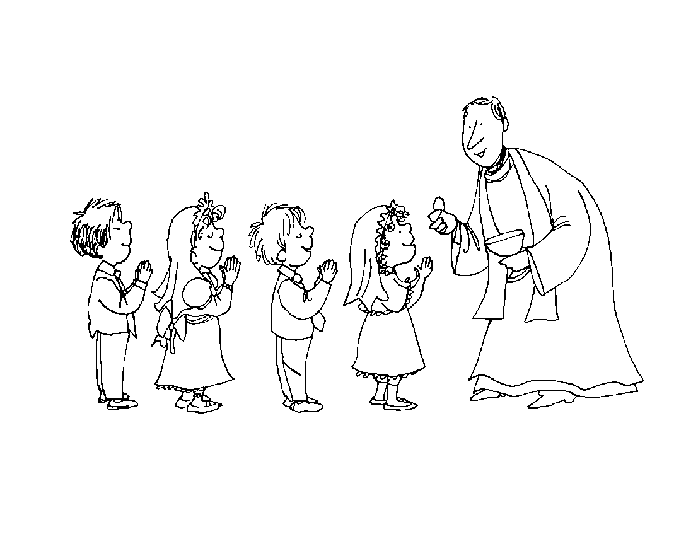If you have any questions/comments/concerns, please contact The Faith Formation Office at 838-9983 or tammie.mang@olp.org

