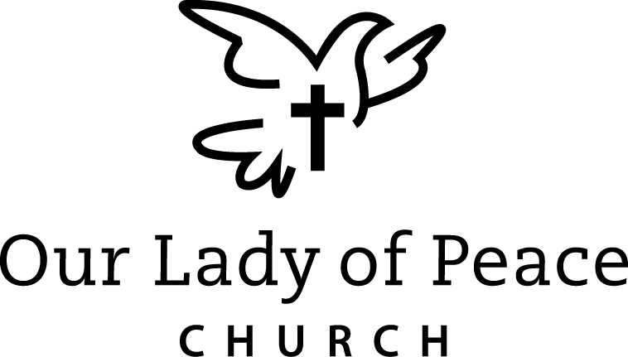
2022-23 FAITH FORMATION REGISTRATION FORM

GRADE 1 THROUGH GRADE 9 Office use only
Posted ( )
Photo Rel (Y) (N)

STUDENT LAST NAME________________________________________

There is a separate form for Confirmation students who will be in grade 10 and 11,
do not include them on this form.

Student Name | Gender | Birth  Date | Grade  In Fall | School Attending  In Fall

Parent Information:

Provide information for custodial parents. If parents live together write “same” for address & home phone under father.

Mother________________________________ Father_____________________________

Address_______________________________ Address____________________________

_____________________________________ __________________________________

Home Phone________________________( ) Home Phone_____________________( )

Cell Phone__________________________( ) Cell Phone_______________________( )
Indicate by checkmark preferred phone for contact during Faith Formation class

E-Mail______________________________________________________________

___________________________________________________________________
List as many email addresses as necessary for all parents

Parish to which you belong: ( ) OLP ( ) Other-Please list_____________________________

If any child is not baptized or is in grade 3 or above has not made First Reconciliation or grade 4 or
above has not made First Communion please list their name(s) _____________________________

________________________________________________________________________________

Any immediate family members not Catholic? For information on becoming Catholic please contact the Faith Formation office at 838-9983 or tammie.mang@olp.org

E
EMERGENCY CONTACT INFORMATION:

If If a parent cannot be reached during Faith Formation class please call:

Fir First & Last Name Relationship Home Phone Cell Phone

F
F FAITH FORMATION FEES: # of Students Amt. Due
Gr. 1-10

If The fee for the 2022-23 school year is as follows:

$ 75 for 1 child
$115 for 2 children
$155 for 3 children
$195 for 4 children ___________ $____________

S Sacrament fee: $15.00 per child* in grade 2 and/or 3 ___________ X $15= $ ____________

Total $_____________

* ( )* Baptized at OLP—provide date_________________
( ( )* Baptized elsewhere—provide Baptismal certificate and include mother’s maiden name

All registration forms and fees, cash or check made payable to “OLP”,
are due no later than August 1, 2022 but would be gladly accepted as soon as possible.
Everything can be dropped off at the church office or the Faith Formation office or mailed to:
Our Lady of Peace Church
Faith Formation Office
2401 W 38th St
Erie, PA 16506

O Office use only
$________ Amt Due

D Date Registered_________ Cash ( ) Check ( ) Ck #_________ $________ Amt Paid

D Date paid _____________ Cash ( ) Check ( ) Ck #__________ $ ________ Bal Due

