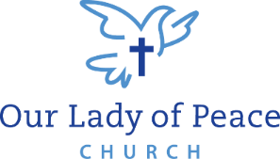
VBS Participant Registration Form
August 1-5, 2022, 8:45 AM to 12:45 PM 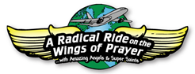
Our Lady of Peace Church
2401 W 38th St, Erie PA 16506
Faith Formation Office phone: 838-9983
$40 per child for the whole week!
===================================================================================
Child’s Information:

Name: _____________________________________________________________________________

Gender: (circle one) M F Age: ___________ Grade in Fall: ____________

T-shirt size: (circle one) child sizes: S M L XL adult sizes: S M L XL 2XL 3XL

Allergies or medical conditions: __________________________________________________________

Health Insurance Carrier and Number (if applicable): ________________________________________

Family Information:

Parents/Guardians’ Name(s): ___________________________________________________________

Address: ___________________________________________________________________________

Email: ______________________________________________________________________________
A confirmation email with further details will be sent July 27, 2022
( ) Mother’s
Phone Numbers: Home: ___________________ Cell: _____________________ ( ) Father’s

Emergency Contact:

Name: __________________________________ Phone: ________________________________

LIABILITY RELEASE: I understand that reasonable precautions will be taken to safeguard the health and wellbeing of the participants in this VBS and that I will be notified as soon as possible in the event of an emergency. In the case of sickness or an accident, I authorize and consent the VBS Team, or other associated volunteers of the VBS program to obtain medical care from a licensed physician, hospital, or medical clinic for my son/daughter in the event that myself or other legal guardian(s) cannot be reached. I hereby do release and forever discharge this Diocese, and Parish from all manners of actions, claims which I or the child named above shall or may have for any reason, arising during my child’s attendance of the VBS.
Unless other written instruction is submitted, I also consent to allowing my child’s image to be recorded, either by photograph or video, and used during the VBS week or for future advertisement of Parish VBS programs. Any other use will require your further consent.

____________________________________________________________ __________________________________________
Parent / Guardian Signature Date

Return completed form with payment no later than Friday, July 8, 2022

