Summer Mission Trip

Join Our Lady of Peace from Erie and Young People Who Care

in Frenchville for a week of service this summer!
June 21 – June 26, 2020
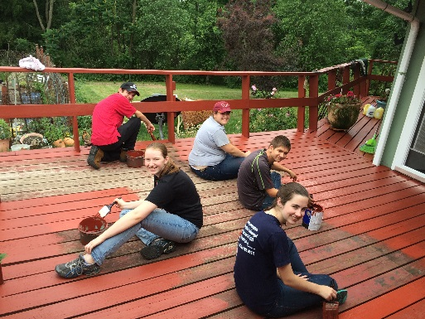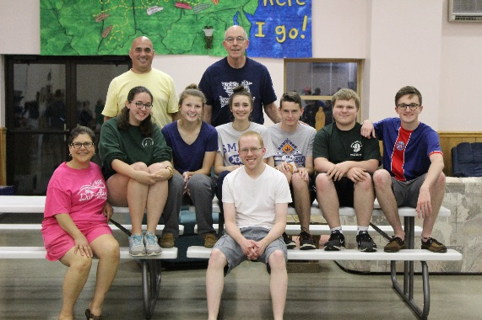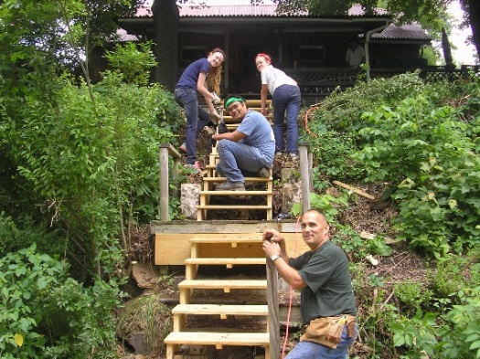

We will travel to Clearfield County PA for a week of social justice outreach and community service. Youth from Evansville Indiana, Pittsburgh Pennsylvania and other areas will join us this week as we share in community, prayer and service to others.

To register: Cost is $250
*(Scholarships covering 50% of cost are available to members of Our Lady of Peace Church.)
Financial assistance may be available if needed. Register, or for more information – contact Darrell Meyers at
darrell.meyers@olp.org
814-450-3697 (call or text)

MINISTRY OF THE WEEK
You will be involved in different ministries throughout the week: painting, yardwork, minor home repairs, nursing home visits, homeless shelter for women and children, assisting at Free Medical Clinic and much more based on the needs of the people in the area. You will work with different students each day and be directly involved in the daily activities on the week: meal prep, recreation, evening reflections.

WHO WE ARE
Young People Who Care, Inc. offers a service program for teens, 16 and older, college students and adults. This program gives participants the opportunity to be involved in social justice outreach in an environment of a Christian Community. This experience includes service to the poor of Clearfield County, community building, prayerful reflection of experience and personal processing time.

Young People Who Care, Inc.
PO Box 129, Frenchville, PA 16836
814-263-4177
www.ypwcministries.org

Our Lady of Peace
www.olp.org
