Session 1
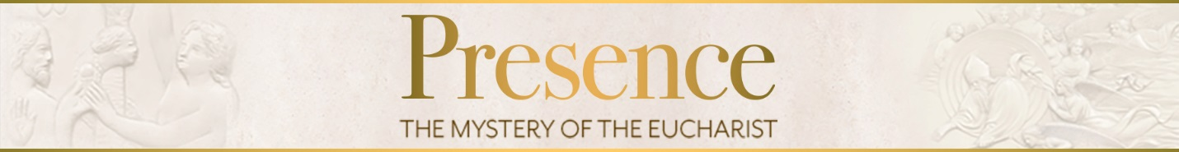

- How is or how can this presence of Christ in the Eucharist be the
source of strength and consolation as you journey through your life?

2. In what ways can you grow in appreciating and embracing Christ’s presence in the Eucharist?

Key points of this session:
- A sacrament is a sign instituted by Christ to communicate his grace to us.

- The Eucharist is the Sacrament of sacraments and the source and summit of the Christian life.

- Transubstantiation means that in the Eucharist the bread and wine really change into the Body, Blood, Soul, and Divinity of Jesus, although they retain the appearance of bread and wine.

- God wants to be united with us, and he accomplishes this through the Eucharist.

Closing Prayer:

Behold, God is my salvation; I will trust, and will not be afraid;
for the Lord God is my strength and my song, and he has
become my salvation.

With joy I will draw water from the wells of salvation. Give
thanks to the Lord, call upon his name; make known his
deeds among the nations, proclaim that his name is exalted.

Sing praises to the Lord, for he had done gloriously; let this
be known in all the earth. Shout, and sing for joy, O
inhabitant of Zion, for great in our midst is the Holy one
of Israel!
Amen

For Further Reading:
Catechism of the Catholic Church, 1077-134 (“The Liturgy-Work of the Holy Trinity” and “The Paschal mystery in the Church’s Sacraments”), 1333-44 (The Eucharist in the Economy of Salvation”), 1373-81 (“The Presence of Christ by the power of his word and the Holy Spirit”), 1996-2005 (“Grace”)

Joan Carroll Cruz, Eucharistic Miracles and Eucharistic Phenomena in the Lives of the Saints (TAN Books: 1991)

Joseph Cardinal Ratzinger, God is Near Us: The Eucharist, the Heart of Life (Ignatius Press: 2003)

Robert Barron, Eucharist (Orbis Books: 2008)

Parent meeting dates: 1. Feb. 9th
2. March 29th
3. April 19th

