Session 3

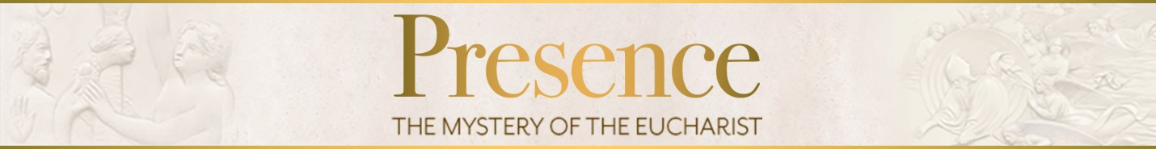

- How do we participate in the sacrifice of Jesus in the Eucharist? What are some practical ways to be intentional about participating in this way?

- At the end of mass, we are dismissed with a purpose. What is our mission when we leave mass? What can we do to live out this mission?

Key points of this session:

- The manna in the wilderness prefigures the Eucharist
- The Eucharist sustains us on our spiritual journey and gives us a foretaste of Heaven.
- In the Mass, we worship with all the angels and saints in Heaven; in the Eucharist we are united to God and to everyone else who is in communion with him.
- The Liturgy of the word includes readings from Scripture, the Responsorial Psalm, the homily, the Creed, and the Prayers of the Faithful.
- The Liturgy of the Eucharist makes present the sacrifice of Jesus on the Cross.
- WE participate in the Mass by offering ourselves to God, united to the sacrifice of Christ.
- We must receive the Eucharist reverently and observe the Church’s rules for doing so.
- The Mass sends us forth with a mission of love.
Closing Prayer:

“O Jesus, concealed in the Blessed Sacrament
Of the Altar, my only love and mercy, I commend
To You all the needs of my body and soul. You
Are Mercy itself. In You lies all my hope.”
-Saint Faustina

For Further Reading:
Catechism of the Catholic Church, 817-22 (“Wounds to unity”), 1140-44 (“The celebrants of the sacramental liturgy”), 1345-55 (“The Liturgical Celebration of the Eucharist”), 1359-61 (“Thanksgiving and praise to the Father”), 1373-81 (“The presence of Christ by the power of his word and the Holy Spirit”), 1384-90 (“Take this and eat it, all of you: communion”), 1422-84 (“The Sacrament of Penance and Reconciliation”), 1524-25 (“Viaticum, the Last Sacrament of the Christian”), 1854-64 (“The Gravity of Sin: Mortal and Venial Sin”), 2041-43 (“The Precepts of the Church”), 2180-83 (“The Sunday obligation”)

Edward Sri, A Biblical Walk Through the Mass: Understanding What We Say and Do in the Liturgy (Ascension Press: 2011)

Scott Hahn, The Lamb’s Supper: The Mass as Heaven on Earth (Doubleday:1999)

Scott Hahn and Regis J. Flaherty, editors, Catholic for a Reason lll: Scripture and the Mystery of the Mass (Emmaus Road Publishing: 2004)

Parent meeting dates: 1. Feb. 9th
2. March 29th
3. April 19th
Meetings are at 10am in the school cafeteria

