Session 2
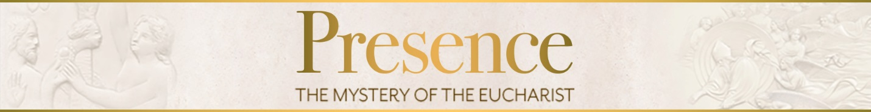

- Why do you receive the Eucharist?

- What do you hope for or expect this sacrament to accomplish in you?

Key points of this session:
- The Eucharist is prefigured in the bread and wine offered by Melchizedek, in the Passover (it is the new Passover), and in the manna in the wilderness.
- Jesus prepares his disciples for the Eucharist by changing water into wine and multiplying loaves of bread.
- Jesus teaches explicitly about the Eucharist in John 6 and lets many followers leave because they don’t like this teaching.
- The Death and Resurrection of Jesus begin a new Creation
- The Cross is the new Tree of Life, and the Eucharist is its fruit.
- The fruit of the Tree of Life opens our eyes to behold God and gives us eternal life.
- The Eucharist is the memorial of Jesus’s Passion, Death, Resurrection, and Ascension.

Closing Prayer:
O saving Victim, opening wide the gate of heaven to man below:
Our foes press on from every side; Thine aid supply, Thy strength bestow.

To Thy great Name be endless praise, immortal Godhead, on in Three!
O grant us endless length of days in our true native land with Thee.
Amen

For Further Reading:
Brant Pitre, Jesus and the Jewish Roots of the Eucharist (Image:2016)
Catechism of the Catholic Church, 1333-44 (“The Eucharist in the Economy of Salvation”), 1362-72 (“The sacrificial memorial of Christ and of his Body, the Church”), 1391-1401 (“The fruits of Holy Communion”)
Pope St. John Paul ll, Ecclesia de Eucharistia Encyclical Letter on the Eucharist in its Relationship to the Church (2003)
Tim Gray, Sacraments in Scripture: Salvation History Made Present, Chapter 1 “Sacraments in Scripture” and Chapter 4 “Sacrament of the Eucharist” (Emmaus Road:2001)
Parent meeting dates: 1. Feb. 9th
2. March 29th
3. April 19th
Meetings are at 10am in the school cafeteria

