Our Lady of Peace – Faith Formation
Confirmation grades 9 & 10
Current Community Service opportunities
Contact: Darrell Meyers (dmeyers@olp.org) 814-450-3697 to register for these opportunities.
39th Annual Festival of Trees – November 24-26
It’s October- Festival of Trees is just a month away.

The information for this year’s 39th Annual AHN Saint Vincent Festival of Trees can be found online at www.supportahn.org/festival.
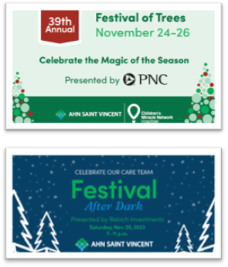

It takes more than 300 volunteers to make Festival of Trees a success. We need support to help with children’s activities during the event and event clean up. Volunteers who participate enjoy the festive atmosphere and opportunity to team build all while creating an important fundraising initiative for the patients AHN Saint Vincent!

Our 2023 Festival volunteer opportunities are below:
If you have students (13+) who would like to volunteer, they are welcome.
All students will receive a letter confirming their volunteer hours.
Parent/guardian will need to sign in children in front of room 110 at the Bayfront Convention Center.
Help During the event: Santa’s Castle, Teddy Bear Clinic: https://www.signupgenius.com/go/60B0A4DA9A92AA5F58-volunteers#/

Questions? Contact the Office of Development at svdevelopment@ahn.org

- Community of Caring, Annual Coat Drive, St. Paul’s Church, Erie,PA
Wednesday November 29, 4:00pm to 6:30pm – unloading, unpacking, folding and set up of clothing for distribution.
- Emmaus Soup Kitchen: all times are 3:00pm* (or immediately after school) to 6:00pm
218 East 11th Street, downtown Erie
Monday November 27
Monday December 18
Thursday December 21
Thursday January 18
Thursday February 15
Monday February 19
Monday March 18
Thursday March 21

